CCSA104 Practical Assignment: Managing Security Policies

Task 1: Explore the default policy.
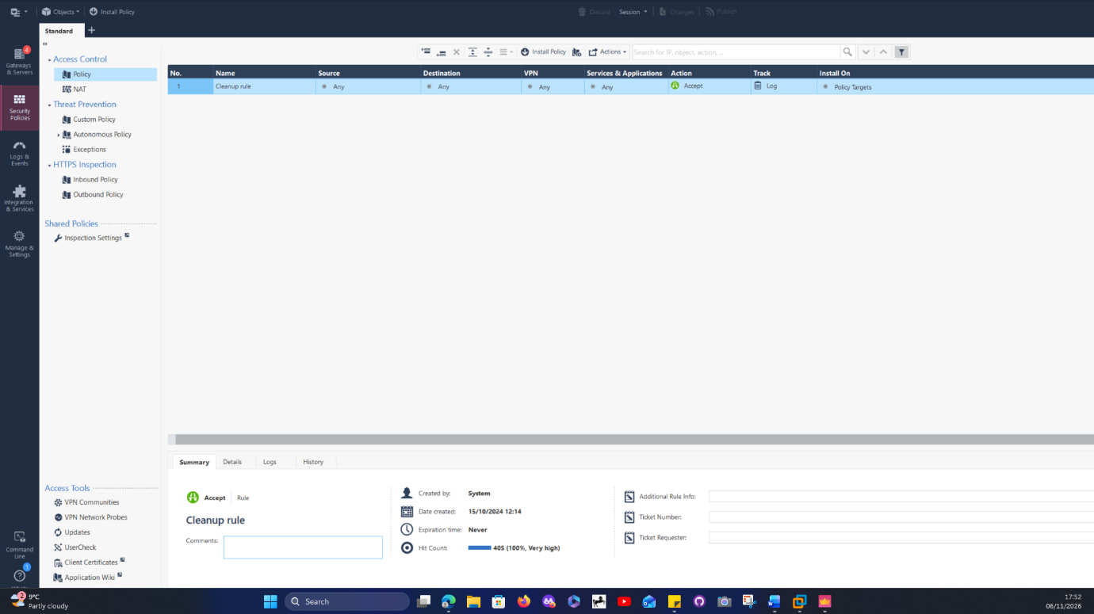
Attribute | Expected value
Name | Cleanup Rule
Source | Any
Destination | Any
Services & Applications | Any
VPN | Any
Action | Accept
Track | Log
Install On | Policy Targets

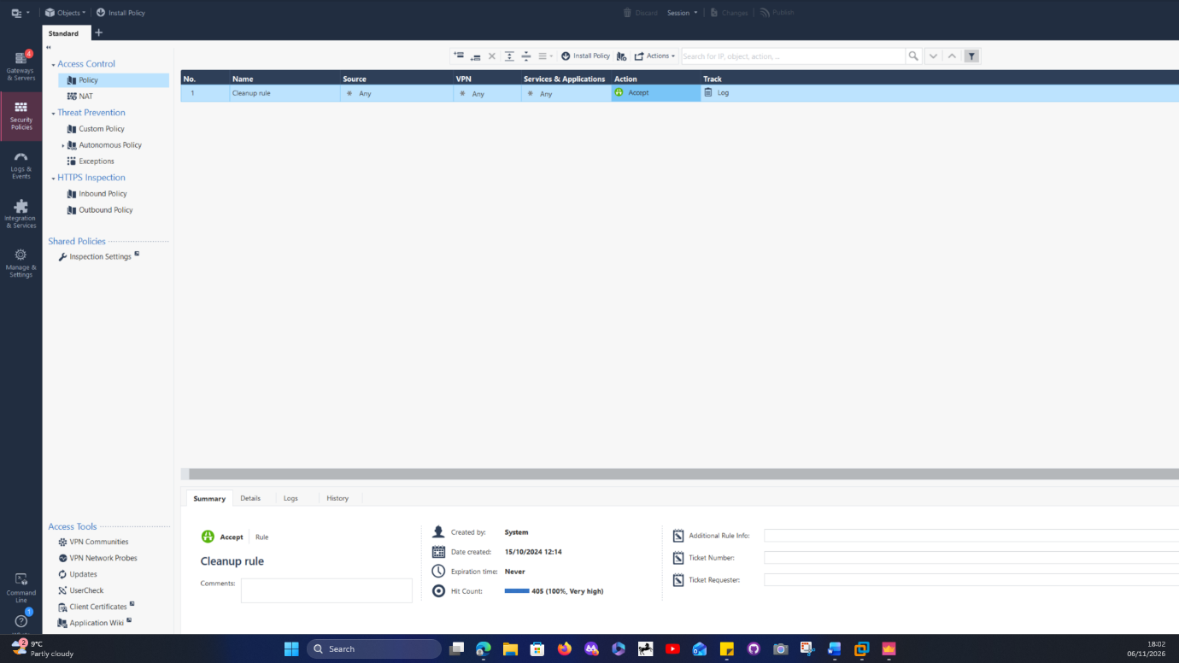
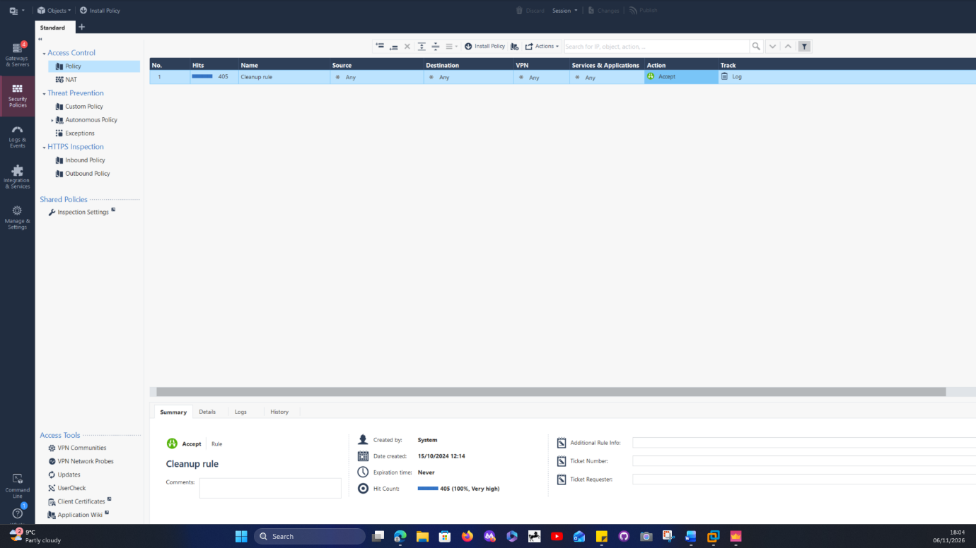
A screenshot of the default rulebase with the extra columns visible, and your table of cleanup rule values.
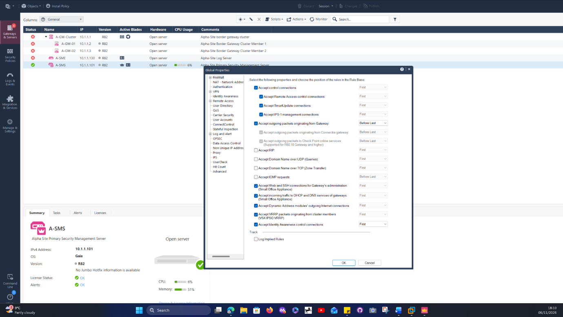
Three categories visible in SmartConsole are:
Firewall settings.
Authentication settings.
Logging and alerting settings.

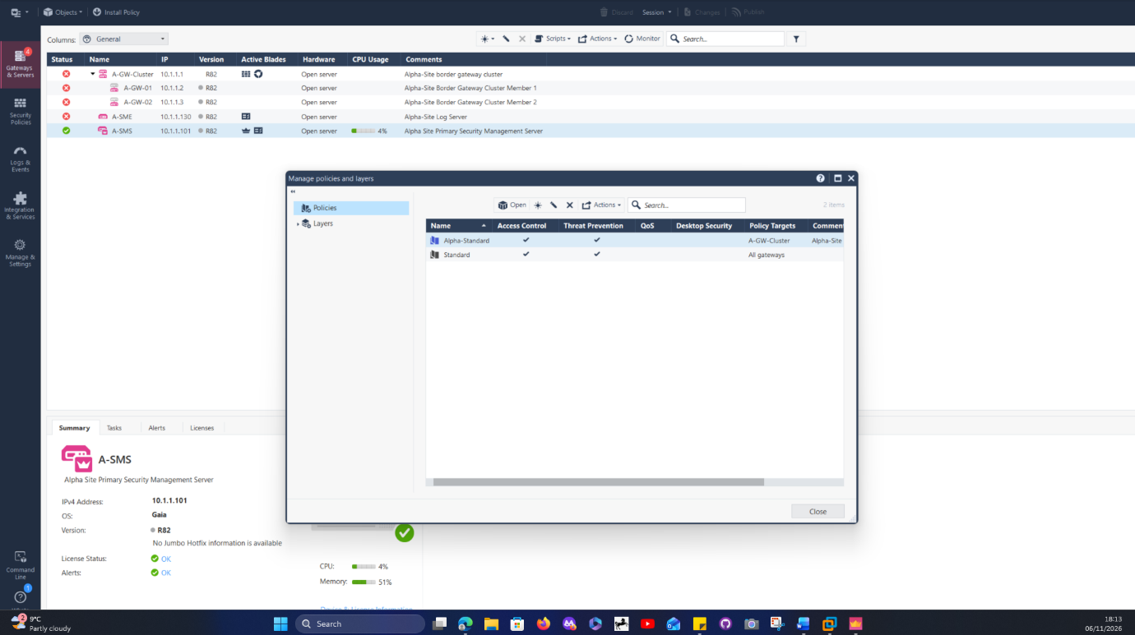

Policy packages that exist in Manage Policies and Layers are:
- Alpha-Standard.
- Standard.
A screenshot of the default rulebase with the extra columns visible, and your table of cleanup rule values.

Task 2: Building the Access Control rulebase
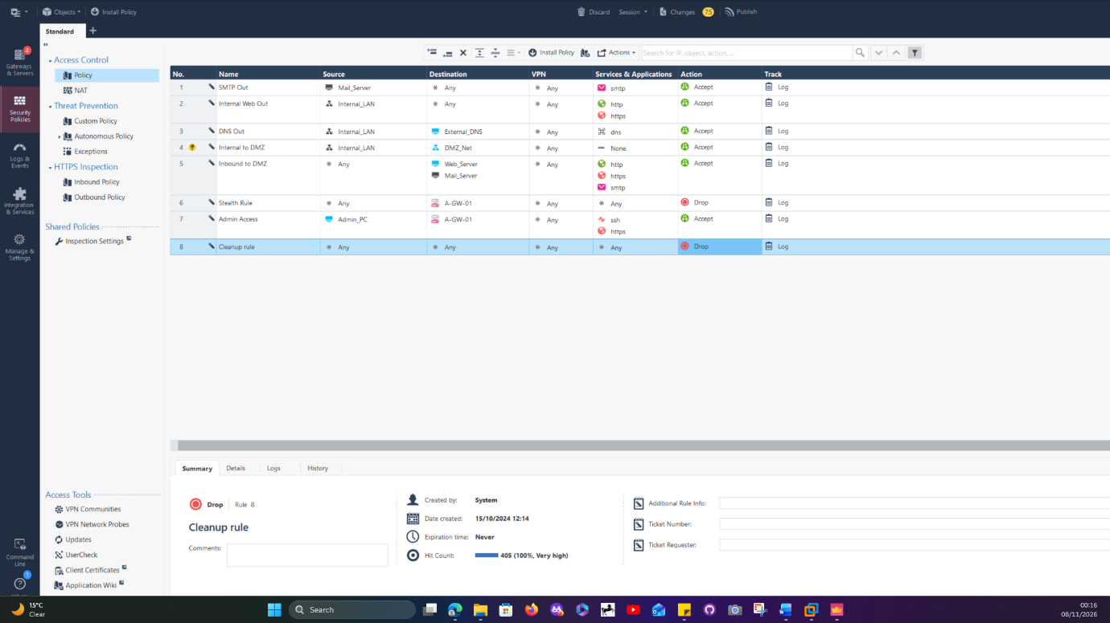
Task 3: Organising the rulebase with sections
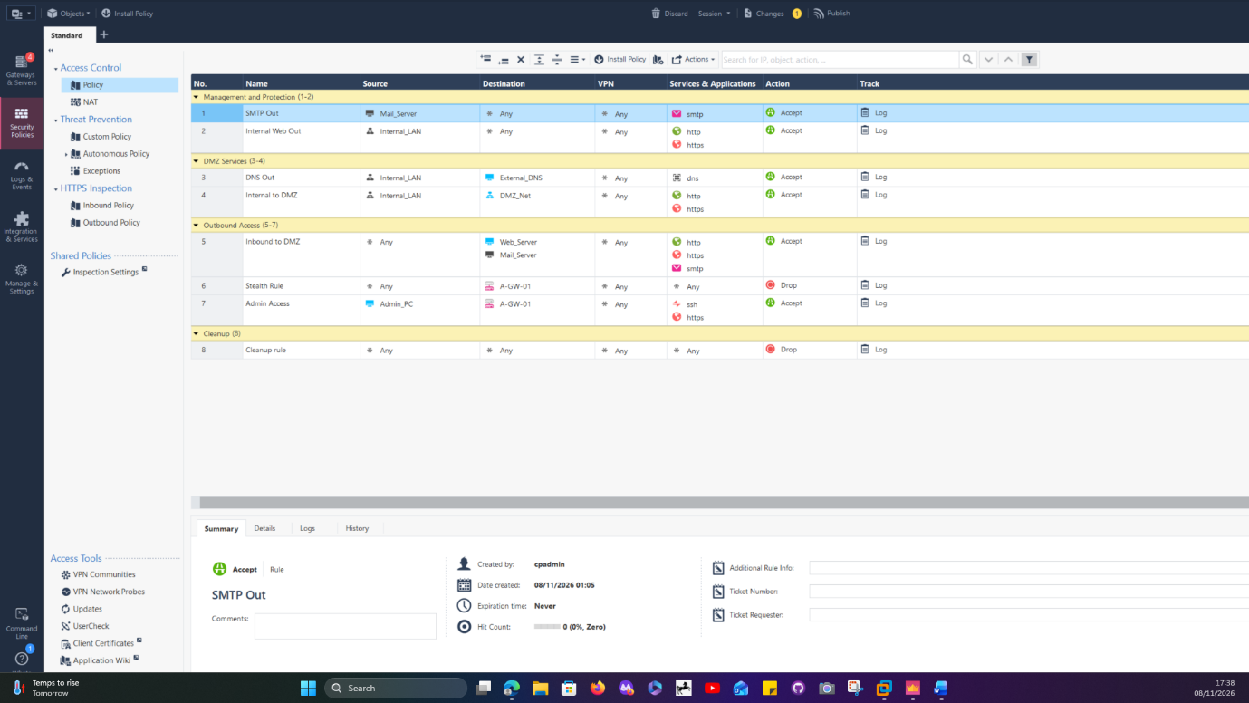
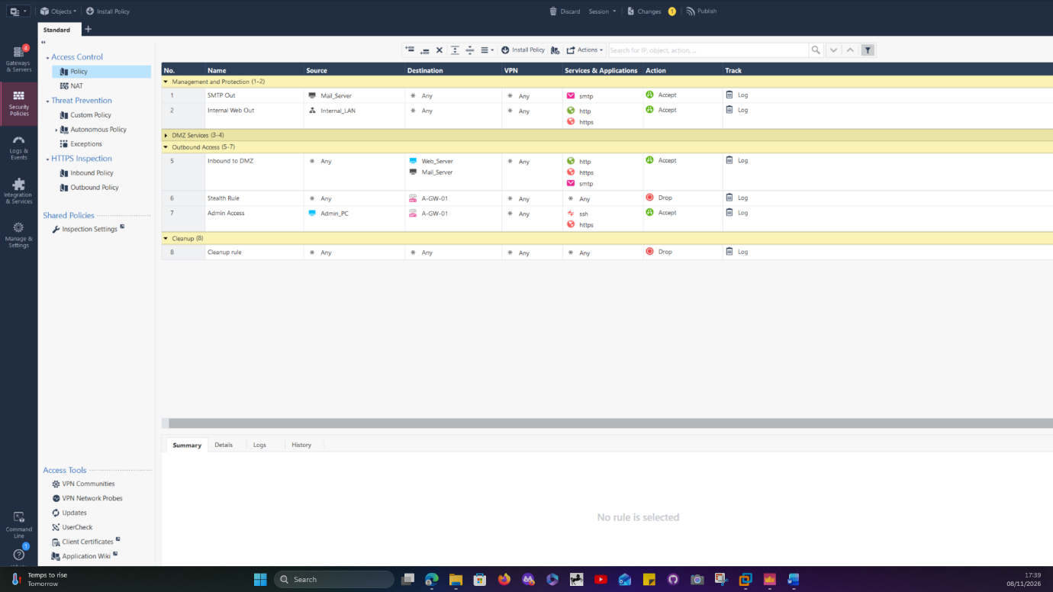
Section titles improve readability and administration. They do not independently enforce security; the individual rules determine the traffic permitted or denied.

Task 4: Configure Hide NAT
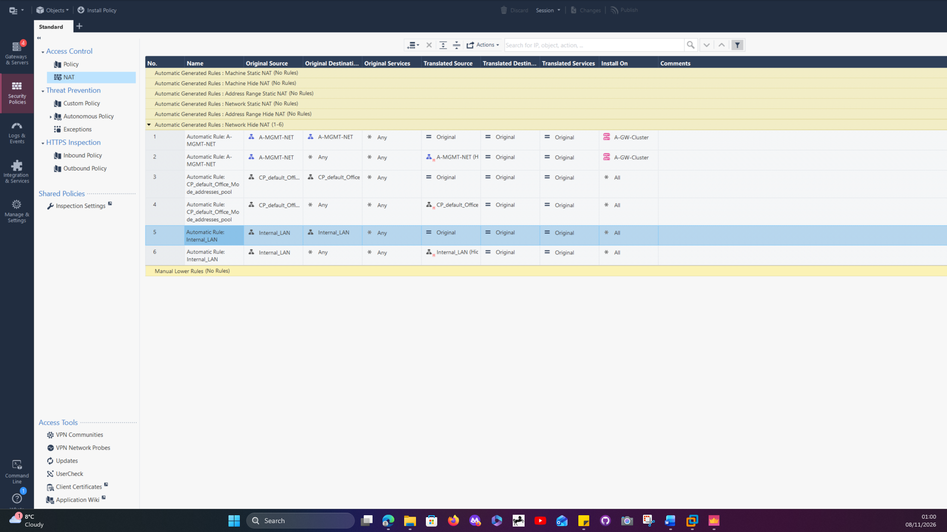
This is an automatic NAT rule because Check Point creates the translation rule when Hide NAT is enabled on a network or host object. This means the administrator does not need to configure the NAT rule manually. The gateway handles the translation automatically when internal devices access external networks.

Many-to-one Translation
Many-to-one translation allows multiple internal devices to share one public IP address when accessing the Internet. For example, several computers on the 10.1.1.0/24 network can use the gateway's external IP address to communicate externally. This helps conserve public IPv4 addresses.

Section B1: Multiple-choice questions
Question | Answer
Q1 | B
Q2 | A
Q3 | C
Q4 | D
Q5 | B

Q6
Explicit rules are rules that an administrator creates manually in SmartConsole. They control network traffic by specifying details such as the source, destination, service and action (Accept or Drop).
Implied rules are automatically provided by Check Point to allow essential system and management communication. Unlike explicit rules, administrators do not create them manually.
Implied rules are configured through Global Properties in SmartConsole. They can be positioned before or after the explicit rules, depending on the selected configuration.
The Implicit Cleanup Action is the default action taken when network traffic does not match any rule in the rulebase. Normally, this means the traffic is dropped, helping prevent unauthorised connections.

Q7
Rule order is important because the firewall checks traffic against the rules from top to bottom. Once traffic matches a rule, the firewall applies that rule's action, so a later rule may never be reached.
For example, in my rulebase, I might have an Accept rule allowing all traffic from the Internal_LAN network, followed by a Drop rule intended to block HTTP traffic.
The problem is that the first rule already allows all traffic, meaning the second rule will not have the intended effect.
To fix this, I would move the more specific Drop rule above the general Accept rule. This ensures that restricted traffic is blocked before the broader permission is applied.

Q8
Saving changes in SmartConsole keeps them in my private working session, allowing me to return to them later without making them available to other administrators.
Publishing is different because it commits those changes to the Security Management Server, making them part of the shared configuration.
If I install a policy without publishing my changes first, the unpublished changes will not be included in the installation. Only the published configuration is used.
Many organisations publish changes during an approved change window because they want to avoid unexpected problems with their network. It also gives administrators time to review and test changes, obtain approval and prepare a backup or rollback plan if something goes wrong.
Q9
Global Properties and Policy Packages both help manage Check Point security, but they serve different purposes.
Global Properties control settings that affect the overall firewall environment. For example, they can be used to configure implied rules and other general firewall behaviours. In SmartConsole, I can access them through the Menu and select Global Properties.
Policy Packages contain the actual security policies that are applied to Security Gateways. For example, I could create a rule allowing employees on the internal network to access websites using HTTP and HTTPS. I can open these by selecting Security Policies in SmartConsole and choosing the relevant policy package.
The main difference is that Global Properties control general system behaviour, while Policy Packages define the security rules that manage network traffic.

Q10
The four predefined Security Zones in Check Point are:
- InternalZone is used for trusted internal networks.
- ExternalZone is used for external networks, such as the Internet.
- DMZZone is used for networks hosting publicly accessible services, such as web servers.
- WirelessZone is used for wireless network connections.
Two important rules when assigning interfaces to zones are:
- Each gateway interface can only be assigned to one Security Zone.
- An interface must be assigned to the appropriate zone before it can be used in zone-based firewall rules.
One benefit of using Security Zones is that they make firewall rules easier to manage. Instead of creating separate rules for individual interfaces, administrators can control traffic between groups of networks based on their security zones.
Section B3: Scenario questions
Q11
Placing an Any-to-Any Accept rule above the Stealth rule creates serious security risks.
Firstly, it allows traffic from any source to reach any destination using any service. This means potentially malicious or unauthorised traffic could enter the network without being properly restricted.
Secondly, it could expose the Security Gateway itself to unwanted connections. Because the Accept rule is above the Stealth rule, traffic intended for the gateway could be allowed before the Stealth rule has a chance to block it. This could expose services running on the gateway to potential attacks.
To correct this, I would remove the unrestricted Accept rule and move the Stealth rule towards the top of the rulebase, immediately after the necessary Management rules. I would then create specific rules that only allow the traffic required by the organisation.
The type of rule allowed above the Stealth rule is a management rule. This is because authorised management systems need to communicate with the Security Gateway to carry out administrative tasks, such as managing and monitoring it.
Q12
1. Saves public IP addresses: Hide NAT allows several devices on an internal network to share a single public IP address when accessing the Internet.
2. Protects internal addressing: It hides the private IP addresses of internal devices from external networks, making the internal network structure less visible.
1. Check the NAT configuration.
I would first check that Hide NAT has been configured correctly for the Internal_LAN network. I would also make sure that the correct external interface or public IP address has been selected. This is important because if NAT is configured incorrectly, internal devices may not have their private IP addresses translated into a valid public address when accessing the Internet.
2. Check the firewall access rules.
Next, I would check the Access Control rulebase to make sure traffic from Internal_LAN to the Internet is allowed. I would also check that the required services, such as HTTP and HTTPS, are permitted and that the rule is above any conflicting Drop rules.
This matters because configuring NAT does not automatically allow Internet access. The firewall must also have a rule permitting the traffic.
3. Check the gateway's routing and connectivity.
Finally, I would check that the Security Gateway has a working default route pointing towards the Internet router. I would also check that the external interface is active and that the gateway can communicate with its next-hop router.
This is important because even if NAT and firewall rules are configured correctly, users will still be unable to access the Internet if the gateway does not know where to send outgoing traffic.

